Feb 3, 2016 at 10:30pm

[Quote](https://cicada3301.boards.net/post/21/quote/17)[like](https://cicada3301.boards.net/thread/17/positions-runes-pages-55)

Post Options

**Post by mortlach on Feb 3, 2016 at 10:30pm**

Here are the positions of each rune in pages 0 to 55  
  
[pastebin.com/ivHPrR8d](http://pastebin.com/ivHPrR8d)  
  
Starting with First rune ᛋ = 1 ending with ...ᛞᛂᚢᛒᛖᛁ = .... 12951, 12952, 12953, 12954, 12955, 12956  
  
  
I have not considered any numbers from the text. Mostly, I think this acceptable, apart from the number 7 found on page 10. If the position of runes is important for something maybe this 7 should be included? The 7 appears after rune number 4295, so it should be easy to amend the above data to take the 7 into account.  
  
Why is the useful?   
  
I'm not sure, but it might be.  
  
One interesting thing you can do with this data is find out the number of runes to the next rune of the same type.   
  
Here is a graph of that:  
  
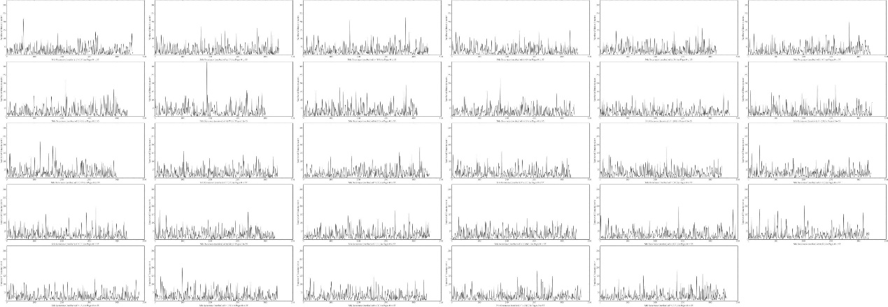  
[i.imgur.com/ktm7B0A.jpg](http://i.imgur.com/ktm7B0A.jpg)  
  
From this data you can tell that G is more regularly distributed than other runes. Or that there is a large gap of ~300 runes with no W. etc.   
  
Here are the positions of the repeated runes. ( ᚠᚠ, ᚢᚢ, etc )  
  
[pastebin.com/D6jQ0ezh](http://pastebin.com/D6jQ0ezh)  
  
They are fairly evenly spread throughout the text, but there are some 'jumps' where there are no repeated runes for ~600+  characters:  
  
[i.imgur.com/cqZJwl7.png](http://i.imgur.com/cqZJwl7.png)  
[imgur.com/cqZJwl7](http://imgur.com/cqZJwl7)